PROGRESS REPORT KELOMPOK 4

Reservasi Tiket Bioskop

Wahidatin Haqqur Rahmah

M.Ilham Habibie

1. ERD

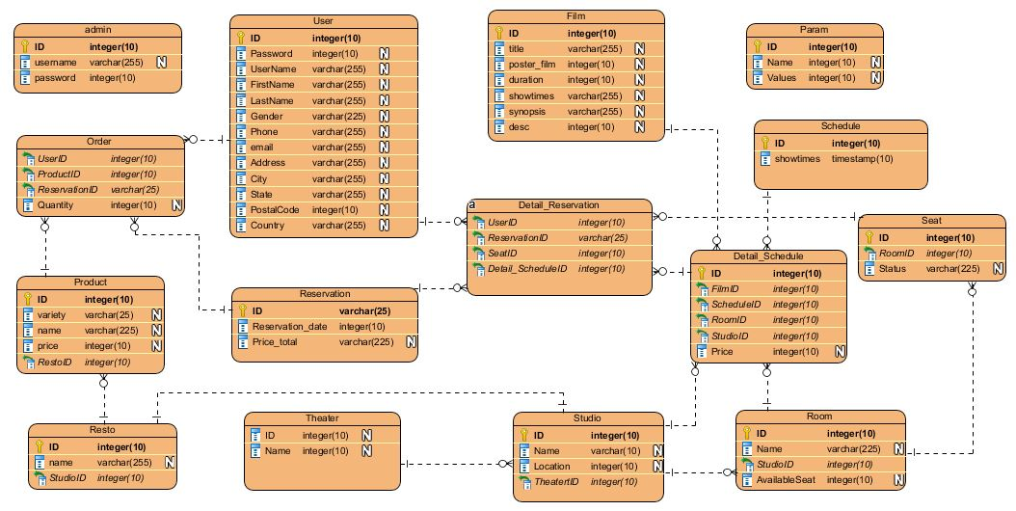

1. Use Case Diagram

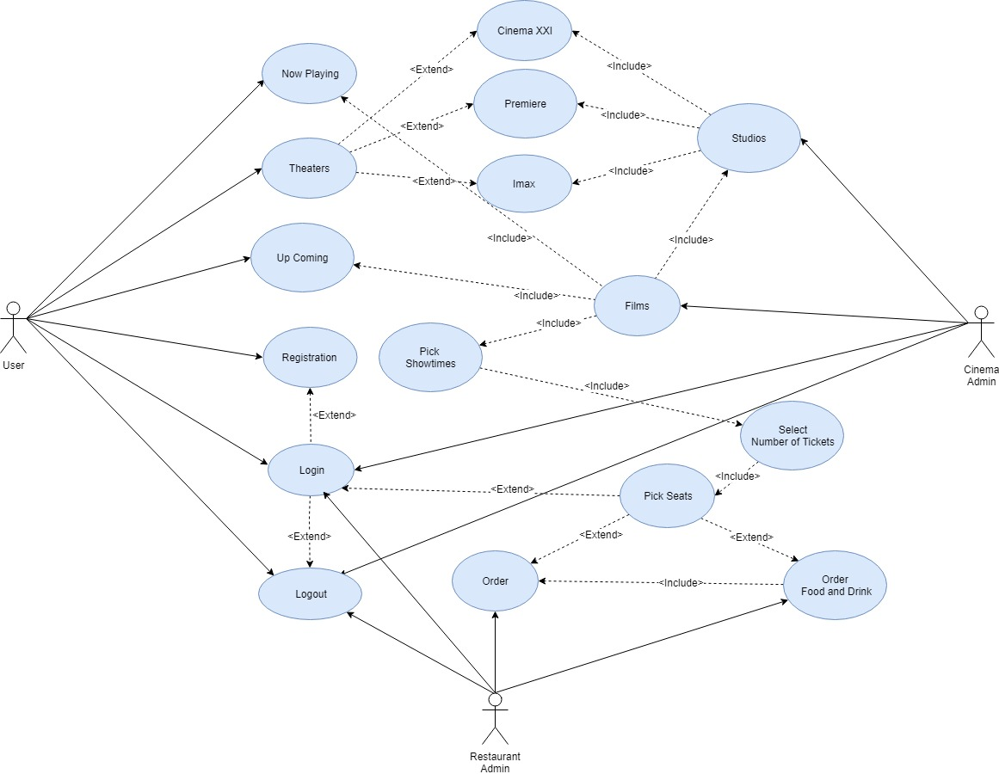

1. Class Diagram

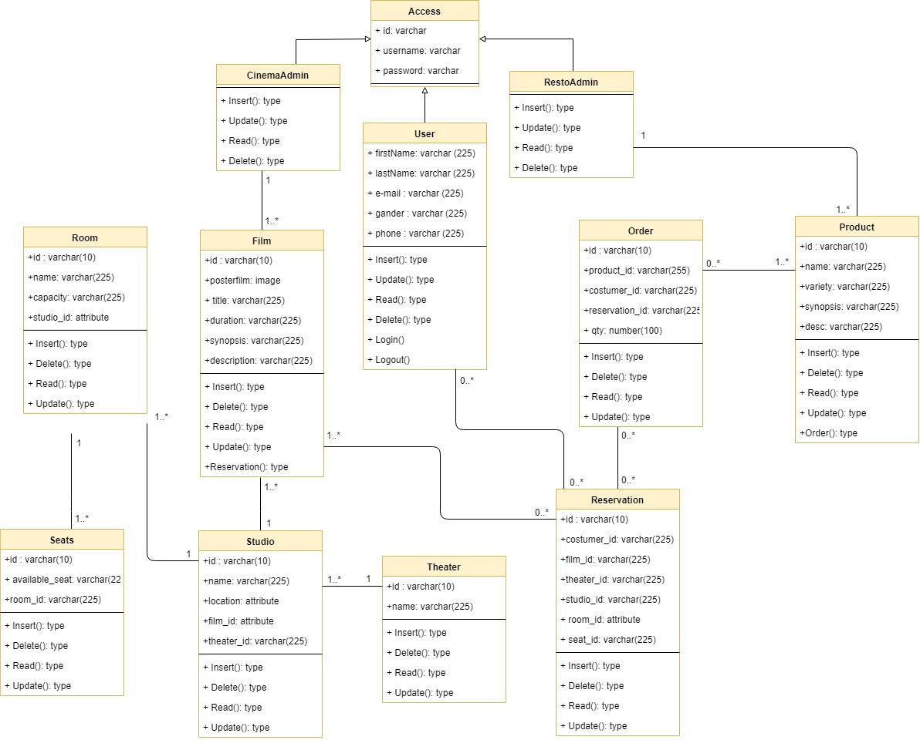

1. Activity Diagram

* Login Admin Cinema

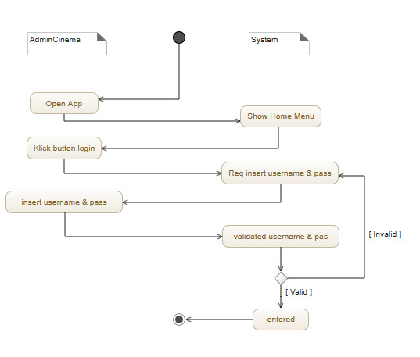

* Login Admin Resto

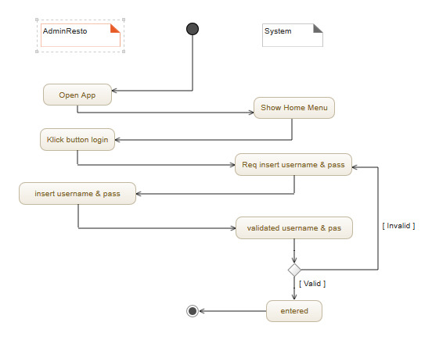

* Login User

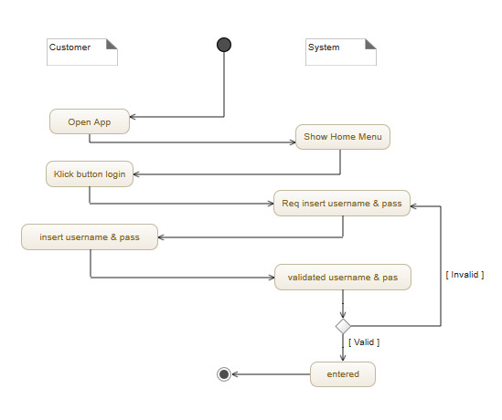

* Logout Admin Cinema

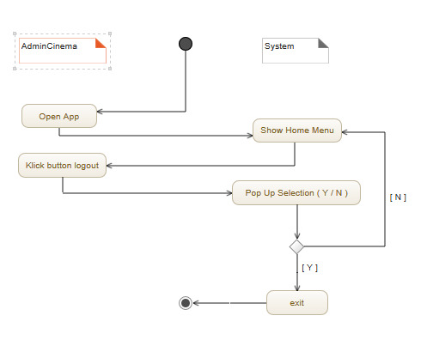

* Logout Admin Resto

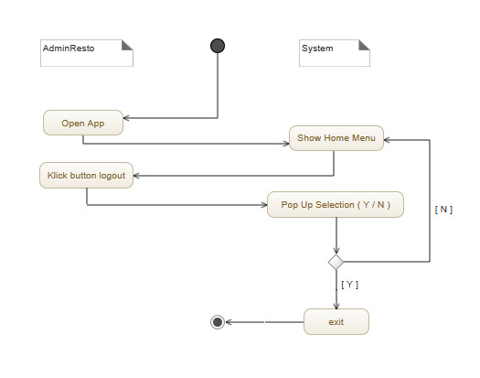

* Logout User

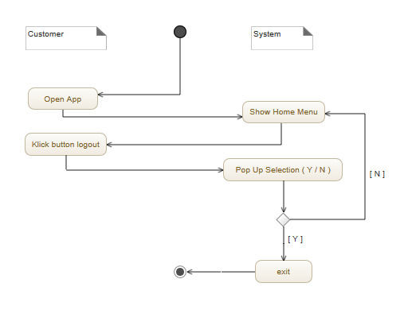

* Regristrasi User

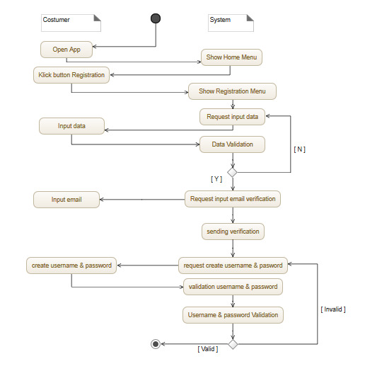

1. Database on progress mas, sudah buat tabel tp belum insert data dan cek relasi